**CALAHEX (Caribbean and Latin America Hybrid Exchange System) Business Model & Financial Idea**

* **Business detailed model**

Shareholders' meeting

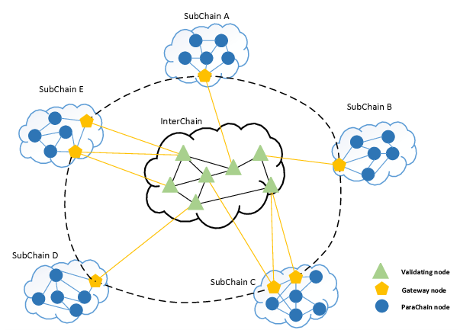

ERC20

ERC20

ERC20

Fund Committee

-Profitability review

-Profit dividend

-Publish Token

Audit meeting

* Supervise & control
* Fairly calculation the increase price of tokens
* Construction
* Medicine
* Material
* …

**Investment**

* **Financial solutions**
* Using Trust Unit Idea

I suggest to use Trust Unit when user buy tokens.

Ex:

User 1 -> Buy 1Token -> 1Trust Unit -> Invested Company or Part 1 -> Profit Contract (ex: yearly, 12%)

-> Buy 2 Token -> 2Trust Unit -> Invested Company or Part 2 -> Profit Contract

…

User 2 -> Buy 3 Token -> 3Trust Unit -> Invested Company or Part 3 -> Profit Contract

-> Buy 4 Token -> 4Trust Unit -> Invested Company or Part 4 -> Profit Contract

…

…

Fund Committee should consider the Trust Unit Quote every time and make it can make at least ROI percentage profit.

And if user A wants to transfer some tokens into another invested company or part, committee should calculate his last token’s trust unit quote and next token which he wants to exchange ‘s trust unit quote.

And using them, transfer should be hard coded so that token publishers can’t operate it himself.

While transferring, the exchanging trust unit’s face value should be considered to make safety and avoid risk for total ROI possession on the exchange platform.

When user wants to return his investment, the profit from his investment should be more than his ROI percentage profit anytime so that he can get even ROI profit if his investment is unable to return.

Finally, controlling trust units quote is the main part of Fund Committee’s work and their work should be supervised and controlled by Audit meeting which belongs to Shareholder’s meeting directly.

* Participate private and technical staff token buyers into Fund Committee.

I suggest to operate private and technical staff person’s investment just seems like a registered capital for holding company behind the exchange platform.

In this way, we can expand public token investment more based on bigger registered capital.

But Founders and advisor’s capital is 20% and private capital is 8%, technical staff capital is 2% so even Fund committee is formed with them, funders and advisors can control the committee with their number of voting rights belongs to their invest percentage.

And we need to make Audit meeting which belongs to shareholder’s meeting directly to supervise and control the fund committee so that provide investors transparent any time.

Audit meeting should include founders and advisors only so this can control fund committee on real time transparently.